ICT Gazette

Table of Contents
HYPERLINK \l "Whatpodcast" What is A Podcast?...............1
How to Use Podcasts………….1
Educational Podcasts-The Good and The Bad.…………….2
Editorial……………………………..2

HYPERLINK \l "TOC" What is a Podcast?
Written by Kimberly Harrison
Podcasts are shows that can be downloaded to a computer and synced to an iPod or other mp3 player. Podcasts can also be accessed on demand on any device that is connected to the internet. Anyone with a microphone or video camera, computer, and access to the internet can create a podcast. There is a podcast out there for everyone with topics ranging from gardening to investment advice. If you find a podcast you like, you can subscribe to it and have new shows delivered to you automatically by using a tool called a “pod catcher” such as Apple’s iTunes app.
LEARN MORE: Good Example of a Podcast

How to Use Podcasts
Written by Kimberly Harrison
The use podcasts are limitless. Listening to a podcast can be relaxing, informative, or entertaining. Users can experience discussions about government, education, technology, politics, health, or a wide variety of special interests. Those who create podcasts use them as a way to introduce audiences to their business, to new music, or even gardening tips. What makes podcasts nice is that there are no limits to what can be discussed or companies censoring what is said. Obviously anything that is against law will more than likely be reported to authorities. Podcasts can also be used for the classroom, which allows teachers to go over weekly assignments.

HYPERLINK \l "TOC"Educational Podcasts—The Good and The Bad
Written by Kimberly Harrison
Podcasts have varying degrees of usefulness and educational podcasts are no different. For me, it is difficult to find specific podcasts that I can label as “poor” in general. However, I would recommend that educators avoid any programs for students that are longer than 30 minutes for older students and any that are longer than 10 minutes for younger students. I would also recommend that educators avoid podcasts that call themselves “educational” but are more along the lines of gossipy or lack direction. There is one podcast that I did find to have little to no value. The podcast Teacher’s Lounge was (in my opinion) too long at over 59 minutes per episode and it seemed more like a group of friends sitting around a table gossiping over coffee. I was expecting it to be more helpful and insightful for teachers in the classroom.
I found two podcasts that I feel are great examples of educational podcasts. The first is Bedley Brothers, which average about 30 minutes in length and cover topics meant to keep teachers informed and connected to what is current and what works in the classroom. The brothers have a combined total of almost 45 years of classroom experience and some of their podcasts feature interviews with education experts and discussions about topics facing teachers today. One example is whether or not schools should filter the Internet for their students?
A second podcast that I think is really great are TED-Ed. I have always found TED Talks to be informative and popular. In addition to the TED podcasts, I have seen TED Talks programs on television and online. I think what makes this a great educational podcast is that it can be viewed as a video or listened to as an audio podcast. The videos may provide more interest for students than the regular audio podcasts. TED also provides Apps for iPhone, iPad, Google Play, and Amazon.
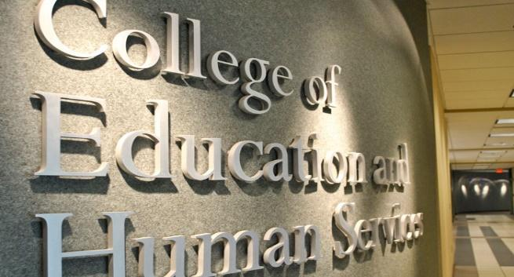
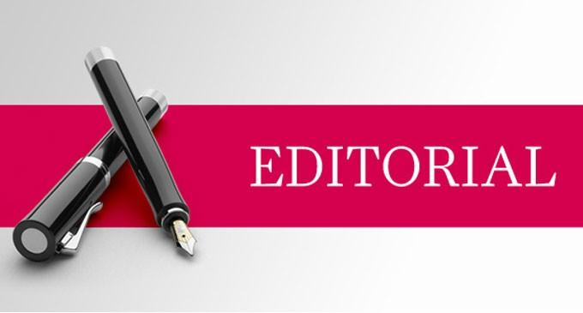

Written by Kimberly Harrison
Are HYPERLINK \l "TOC"Educational Podcasts Worth the Time?
Podcasts are great for people that have the time to listen to them. Personally, I haven’t found any educational podcasts that peak my interest. However, I think using podcasts in the classroom may have some benefit for a variety of reasons. First, teachers can discuss the lessons that were taught during the week. This would come in handy for students who are absent or might need more processing time because of a learning disability. Another good use would be to discuss concepts that students might have had problems understanding or to introduce any upcoming topics that need a more in depth introduction.
As for podcasts that are meant for a large audience, I’m not 100% sure how effective they would be unless it had some sort of hook to get and keep the listeners’ attention. This is especially true for younger students. I feel that videos like those on TED Talks would have a bigger impact because students today are used to visual stimulation.
Creating a podcasts is time consuming and most teachers don’t have enough hours in the day as it is, so having a good educational technology department would come in handy. Another idea would be to have local college students who are in a technology or education program create and manage the podcasts for class credit. Podcasts prove that the possibilities are endless when it comes to what can be covered. If educators are looking to make money with their podcast then it may not be worth the time, effort, or energy. However, if educators are looking to supplement their students’ learning with a class-related podcast then it may very well be worth it.
